

Swami: The Next Generation Biology Workbench

Swami Database Specification
Draft of May 19, 2006

Dr. Rami Rifaieh
Integrative BioSciences
San Diego Supercomputer Center
UC San Diego MC 0505
9500 Gilman Drive
San Diego, CA 92093
Subject
This document describes the specification and the requirements of the SWAMI database. It aims at suggesting a conceptual modeling that can be implemented later on.
Change History

Author | Date | Version | Comments
Rami Rifaieh | 19 May 2006 | V01 | Creation
--

Contents
1 Introduction 5
2 Existing DB for Molecular biology 5
3 DB variety and Format 6
4 How to tackle the Data Integration problem 7
5 Existing Works for Integrating Biological Data 8
6 Interesting Data Warehouse Approaches: 11
7 Available Extraction Transformation Load Tools & APIs 13
8 Suggested Approach 14
9 Implementation issues & APIs 16
10 Related Issues 17
11 Appendix (Similar projects) 18
12 References: 19

Introduction
Currently biologist students and researchers have to spend an extensive amount of time in order to collect the data that they are interested in (e.g. gene sequences, protein structures, etc.) and to organize these data together before starting to manipulate them with different tools (Blast, ClastlW, NBlast, etc). In this respect, the Swami project helps users to reduce the task of collecting, storing, and manipulating data. It provides an accessible portal that offers a subset of the public genomics databases, a user storage space, and a set of tools to manipulate and annotate biological data [1].

Requirements
Therefore, the project should include two databases: one is a public database which combines the data collected from the public resources. The second include a set of user data that are stored, organized, and annotated by the users. The first represent a public space where all users can query and search. The second represents a user space that is only accessible for a unique user. The data that are stored under each space is almost identical (gene sequences, etc. ) but personalized by the user (user annotations, results, etc.). Therefore, it is very interesting to organize data in both spaces in a similar way.

The fuzzy word of biological database has many meaning in current molecular biology where computer scientists and biologist don’t share the same view. Indeed, for biologist a database can represent the set of known information concerning a special protein or a special sequence that can be stored in a text file, a relational database record, etc. For computer scientist, a database is a set of data collected and organized with respect to a DB schema (in general relational), managed with a DBMS (Oracle, DB2, MySQL, PostgreSQL, etc.), and available on a database server.

This same issue was raised in [5], where author claim to deliberately avoided the term genomic database and replaced it by the term genomic repository since many of the so-called genomic databases are simply collection of flat files or accumulation of web pages and do not have the beneficial features of real databases in the computer science sense.

In order to simplify communication misunderstanding, we should try to avoid misusing these vocabularies. Therefore we refer to Resource as any site where data is collected and organized without questioning the underlying storage as relational or textual, etc. We refer to Database to represent a relational, object, or object/relational database. For what is known in biology as database, we use Collection to refer to the information about sequences.

Existing DB for Molecular biology
Yearly, the Nucleic Acids Research Molecular Biology Database Collection provides lists of freely available and public resources throughout the globe which have value to the biologist. The 2006 update includes 858 collections, 139 more than the previous one. The 2005 update includes 719 collections, 171 more than the 2004 one, etc. We can find online the collection’s summaries with brief descriptions, contact details, appropriate references and acknowledgements. The online summaries also serve as a venue for the maintainers of each collection to introduce updates and other improvements [2]. The full list of available collection is given at: http://nar.oxfordjournals.org/content/vol34/suppl_1/images/data/D3/DC1/gkj162_Supp_Table1.doc

Some of these resources can be redundant, for instance GenBank, DDBJ, EMBL include all known nucleotide and protein sequences. Any new submission and update to one will propagate automatically to the others.

Requirements
In the Swami Project, we are interested to integrate a set of these publicly available resources.
With respect to the user requirements and use cases described in manuals on the Wiki [Ref], we reduce this set to include for the prototyping purposes the following: MSD, UniProt Knowledgebase, Embl, Interpro.
<http://www.rcsb.org/pdb/static.do?p=download/ftp/index.html>
<http://www.ncbi.nlm.nih.gov/entrez/query.fcgi?db=taxonomy>
<http://www.ncbi.nlm.nih.gov/entrez/query.fcgi?db=unigene>
<http://www.ncbi.nih.gov/entrez/query.fcgi?db=gene>
<http://www.ebi.ac.uk/FTP/>

This list is not exhaustive since user requirements in term of needed collections may grow with the appearance of new data resources. A more complete set will be included in later implementation. We will try to incrementally to add more resources on demand of the users.

Requirements
Therefore the database structure should be extensible to include the new entries resources. We intend to mirror these collections locally in order to offer faster and consistent results for the Swami’s users.

DB variety and Format
With the globalization of the web, data producers (scientists and research institutes) decided to publish their data online. In general, public biological resources are freely accessible for navigation, querying, searching through specialized websites. For instance, SRS, getentry and Entrez are used respectively for searching EMBL, DDBJ, and NCBI.

Although, these online resources are available with a set of manipulation tools, scientists, researchers and students have to shift from one resource to another in order to get their work done. Making these tools available with the variety of data format and different resources is a fairly complicated task. It requires building a unique environment for data integration, data manipulation, and data store.

Requirements
The Swami project aims at providing a collective set of resources with a set of manipulation tools. It intends to provide users with their own storage space, where manipulated data can be annotated, modified, and curated by the users.

Biological data is available in a wide variety of flavors and formats, annotated, and stored in flat files (ASN.1, FASTA, delimited text, etc.), relational or object-oriented databases (SQL dump), and XML formats. There exist around 40 file formats that can represent data to be integrated into the DB, this includes GBFF, EMBL, etc.

Requirements
Therefore, we need to have a set of API, parser, or syntactical analyzer to extract data from these resources and store them into the Swami database. In data integration terminology these tools are known as Extraction, Transformation, and Load tools.

How to tackle the Data Integration problem
Before starting to resolve the problem of data integration, we should be aware about common difficulties that exist in integrating biological resources. Since biological resources are wide spread between many institutions and research organizations, they don’t share common modeling practices. Therefore, when we try to integrate these resources we have to deal with inconsistency [9], incompleteness, redundancy, and extensibility.

Requirements
For the Swami project, we shouldn’t assume that resources are not necessarily complementary in the sense that they export different parts of the schema (horizontal integration). Rather, we should consider the possibility that these resources may be overlapping in which case aggregation of information is required (vertical integration).

In brief, the effort in the domain of data integration is resumed by two major axes:

Warehousing (data translation): warehouse integration consist in materializing the data from multiple sources into a local warehouse (unified database) and executing all queries on the data contained in the warehouse rather than in the actual data sources. Data warehousing emphasizes the use of Extraction Transformation and Load tools. This requires that all data loaded from the sources to be converted through data mapping to the standard unique schema that is physically implemented under the DBMS. This allows advanced improvement in term of the efficiency of the query execution and query optimization. This allows as well to filter the data and to check the consistency and the redundancy of the integrated data before being used by the end users. The local storage of the integrated data can allow also the user to add their own annotation and the storage of the results in some specific tables created for this end.

Federated/query translation (or mediator based approach): unlike warehousing solution, the mediator ensures query translation versus data translation required in warehousing approach. At the runtime a query given by the user on a single mediated schema will be translated into a set of queries on the local schemas of the underlying data sources. The mediated schema is a virtual since no data is stored in that schema being used by the user. Unlike in the warehouse approach, none of the data in a mediator based integration system is converted to a unique format according to a data translation mapping. Instead a different mapping is required to capture the relationship between the source description and the mediator and thus allow queries on the mediator to be translated to queries on the data sources.

In addition, an alternative approach (navigational) to the preceding two axes was also studied for biological data. It consists on storing intact record in a table and extracts specific fields to index and cross-reference. This category includes implementation such as SRS, Entrez and SeqHound. The main disadvantage of this approach results from loosing the relational modeling which allows rich queries and optimization.

Existing Works for Integrating Biological Data
In the last decade, many projects tried to deal with the integration of biological resources. For instance the Biology Workbench project was one of many other successful implementations.

Due to the competitiveness in this area many resources don’t keep alive and disappear as well as the tools and data that they stored. For instance BioNavigator a search tool that is mentioned in may research paper is not available anymore on the web.

We can identify dozen of tools and projects that aimed at integrating biological data in one or many sub-field of Genomis, Pediomics, etc. The following is a reduce list of federated and navigation apporches:

SRSWWW or simply SRS is the most widely used biological database indexing and query system worldwide. Originally developed by Thure Etzold at EMBL and EBI, it was further developed by Lion Bioscience in Cambridge in collaboration with the EBI. It has many mirror sites around the globe. It uses the navigational model to group and index data from existing resources. In addition to the database query capabilities, SRS includes external application definitions written in the Icarus language.

BioNavigator is a web-based platform for sequence and structure analysis that integrates a large number of applications and databases under a streamlined, intuitive user interface. BioNavigator was designed not only for research but also as a platform for the practical teaching of sequence analysis, with a broad range of industry-standard applications accessible from multiple locations without the need to install specialized software. BioNavigator’s standardized interface enables students to concentrate on using programs rather than wasting time learning how to navigate each program’s interface. A range of educational features including course databases and step-by-step protocols complements the interface. In order to assist teachers wanting to introduce their students to sequence and structure analysis, a bioinformatics education package leveraging the BioNavigator interface was developed. This package includes a collection of protocols and practical bioinformatics problems to be used in practical classes in conjunction with BioNavigator.

Tambis (it includes Tambis ontology): The TAMBIS project aims to provide transparent access to disparate biological databases and analysis tools, enabling users to utilize a wide range of resources with the minimum of effort. A prototype system has been developed that includes a knowledge base of biological terminology (the biological Concept Model), a model of the underlying data sources (the Source Model) and a ‘knowledge-driven’ user interface. Biological concepts are captured in the knowledge base using a description logic called GRAIL. The Concept Model provides the user with the concepts necessary to construct a wide range of multiple-source queries, and the user interface provides a flexible means of constructing and manipulating those queries [6].

LuceGene: is an open-source (built on top of Lucene package) document/object indexing and retrieval system specially tuned for bioinformatics text databases and documents. LuceGene is similar in concept to the widely used, commercially successful, bioinformatics program SRS which is comparable to web-indexing systems such as yahoo, Alta-vista, and Google. LuceGene adds some bio-data methods to Lucene such as: indexing adaptors for formats such as XML, PDF Documents, Biosequences, Spreadsheets, HTML, etc. coming from UniProt/Swiss-Prot, Fasta and GenBank sequences, BIND protein interactions, NCBI Gene Expression Omnibus, BLAST output tables, Medline. LuceGene is speedy with big data sets; searching the UniProt library of 1.7 million sequences with LuceGene is a close equivalent to SRS in speed and content (10x to 20x faster than using a Postgres Chado database).

K2/Kleisli: is similar to a number of other view integration systems. K2 relies on a set of data drivers, each of which handles the low-level details of communicating with a single class of underlying data sources (e.g., Sybase relational databases, Perl/shell scripts, the BLAST 2.x family of similarity search programs, etc.). A data driver accepts queries expressed in the query language of its underlying data source. It transmits each such query to the source for evaluation and then converts the query result into K2’s internal complex value representation. Like Kleisli, the K2/Kleisli system uses a complex value model of data. This model is one in which the “collection” types, i.e., sets, lists, and multisets (bags), may be arbitrarily nested along with record and variant (tagged union) types. Kleisli uses as its language the Collection Programming Language (CPL), which was developed specifically for querying and transforming complex value data. Although equivalent in expressive power to SQL when restricted to querying and producing relational data, CPL uses a “comprehension” style syntax which is quite different in style from SQL.

DiscoveryLink: DiscoveryLink is an IBM offering that uses database middleware technology to provide integrated access to data sources used in the life sciences industry. DiscoveryLink provides users with a virtual database to which they can pose arbitrarily complex queries in the high-level, nonprocedural query language SQL (Structured Query Language). DiscoveryLink efficiently answers these queries, even though the necessary data may be scattered across several different sources, and none of those sources, by itself, is capable of answering the query. In other words, DiscoveryLink can optimize queries and compensate for SQL function that may be lacking in a data source.

BioMart : BioMart is a query-oriented data management system developed jointly by the European Bioinformatics Institute (EBI) and Cold Spring Harbor Laboratory (CSHL). The system can be used with any type of data and comes with a range of query interfaces and administration tools, including 'out of the box' website that can be installed, configured and customised according to requirements. The system simplifies the task of creation and maintenance of advanced query interfaces backed by a relational database and it is particularly suited for providing the 'data mining' like searches of complex descriptive (e.g. biological) data. BioMart can work with existing data repositories by converting them to a required BioMart format as well as newly created databases. BioMart has built-in support for query optimization, which makes it particularly useful when working with large data repositories storing high throughput experiment data such as genomic sequence or microarray experiments. BioMart architecture makes possible to cross-query multiple datasets distributed across the internet, removing the need to integrate and store data locally. BioMart data can be accessed using either web, graphical, or text based applications, or programatically using web services or software libraries written in Perl and Java. Currently supported RDBMS platforms are MySQL, Oracle and Postgres. BioMart software is completely Open Source, licensed under the LGPL, and freely available.

Many papers tried to compare existing projects between each other, these tables reflect some of the elements of these comparison.

Table 1: Analysis of data management capabilities of existing integration systems with respect to the requirements in [5]

 | SRS | BioNavigator | K2/Kleisli | DiscoveryLink | TAMBIS | GUS
Multitude and heterogeneity | User shielded from source details | User shielded from source details | User shielded from source details | User shielded from source details | User shielded from source details | User shielded from source details
Representing genomic data (data model) | HTML | HTML | Global schema using object-oriented model | Global schema using relational model | Global schema using description logic | GUS schema based on relational model; OO views
User interfaces | Single-access point | Single-access point | Single-access point | Single-access point | Single-access point | Single-access point
Quality of user interface | Simple to use visual interface | Simple to use visual interface | Not a user-level interface | Requires knowledge of SQL | Simple to use visual interface | Requires knowledge of SQL
Quality of query language | Limited query capability | Not query oriented | Comprehensive query capability | Comprehensive query capability | Comprehensive query capability | Comprehensive query capability
User interaction with genomic repository | No new operations | No new operations | New operations on integrated view data | New operations on integrated view data | New operations on integrated view data | New operations defined on warehouse data
Format of query results ( output : text files, screen, etc.) | No re-organization of source data | No re-organization of source data | Reorganization of result possible | Reorganization of result possible | Reorganization of result possible | Reorganization of result possible
Managing the inconsistence from similar or overlapping repositories | No reconciliation of results | No reconciliation of results | No reconciliation of results | No reconciliation of results | Result reconciliation supported | Data in warehouse is reconciled and cleansed
Managing the uncertainty of data, correctness, alternatives | No provision for dealing with uncertainty in data | No provision for dealing with uncertainty in data | No provision for dealing with uncertainty in data | No provision for dealing with uncertainty in data | No provision for dealing with uncertainty in data | No provision for dealing with uncertainty in data
Combination of data from different genomic repositories | Results not integrated; sources must be Web-enabled | Results not integrated;  sources must be Web-enabled | Results integrated using global schema; source wrapper needed | Results integrated using global schema; source wrapper needed | Results integrated using global schema; source wrapper needed | Query results are integrated
Extraction of hidden and creation of new knowledge | Not supported | Not supported | Not supported | Not supported | Not supported | Annotations supported
Using biological data types (instead of textual strings and numerical values) | Not supported | Not supported | Not supported | Not supported | Not supported | Not supported
Enabling user self-generated data and extensibility to integrate | Not supported | Not supported | Not supported | Not supported | Not supported | Supported
Support for new specialty evaluation functions (to operate with user data and integrated data) | Not supported | Not supported | Not supported | Not supported | Not supported | Not supported
Storage curation and volatility risks | No archival functionality | No archival functionality | No archival functionality | No archival functionality | No archival functionality | Archiving of data supported
Table 2: More comparison between existing projects as described in [3]:

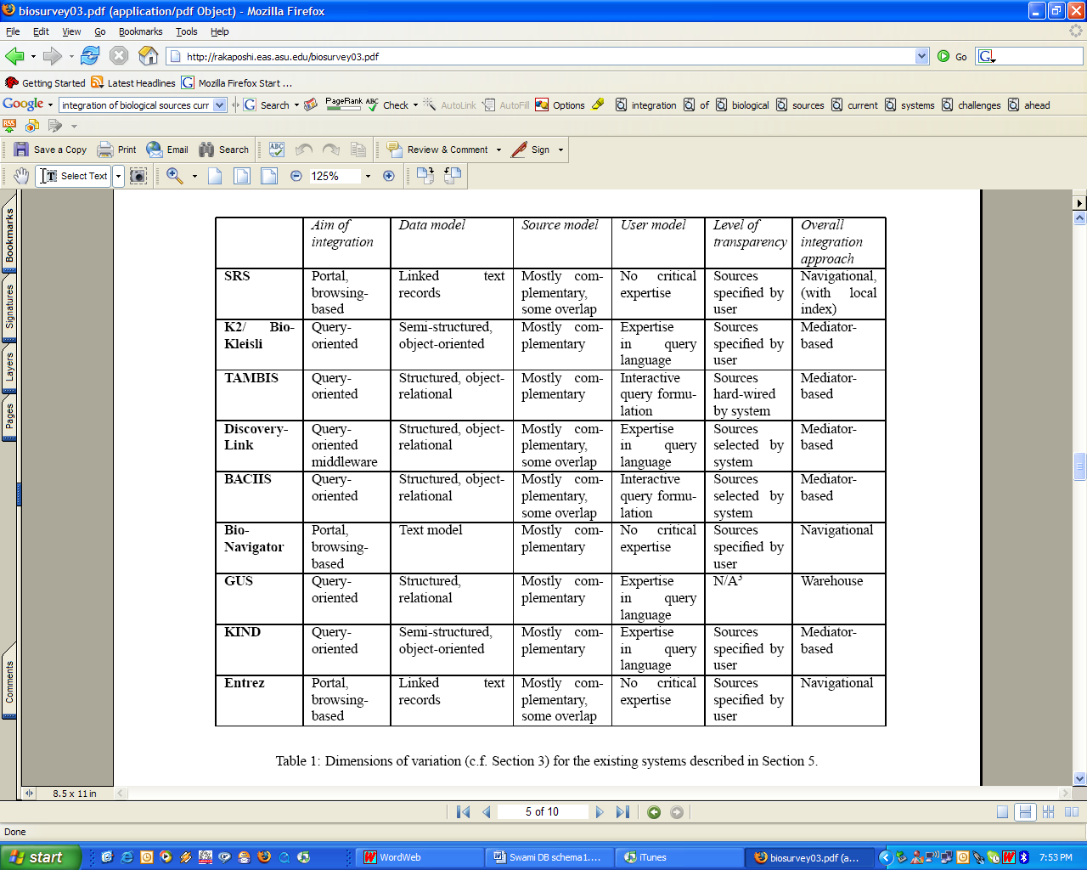

After analyzing these two comparison tables we find that warehousing approaches such as GUS (Genomics Unified Schema) stands up. They offer better management for the inconsistency coming from similar or overlapping repositories. On the other hand, they require users to have some SQL knowledge. The later is not restrictive since the user interface that we are intending to build as part of the Swami project will hide all the SQL from the user front-end. Thought, this allows only a restricted set of queries, advanced users can use SQL to formulate their queries over the warehouse schema.

Interesting Data Warehouse Approaches:
More projects in data warehousing are not mentioned in the preceding section can be useful for our project. These approaches provide a reusable schema and a set of loading tools.

GUS (Genomic Unified Schema) [10]:
The Genomics Unified Schema (GUS) is an extensive relational database schema and associated application framework designed to store, integrate, analyze and present functional genomics data. It emphasizes standards-based ontologies and strong-typing. The GUS Application Framework offers an object-relational layer and a Plugin API used to rapidly create robust data loading programs for diverse data sources. The GUS distribution includes plugins for standard data sources. The GUS Web Development Kit (WDK) is a rich environment for efficiently designing sophisticated query-based websites with little programming required. GUS was designed to warehouse and integrate sequence data and annotations from various heterogeneous sources under a common schema. The advanced schema and support make GUS an attractive foundation for data management in molecular biology applications. It includes 7 major divisions representing approximately 50 concepts in over 400 tables and views: Central Dogma ((DNA RNA protein), Sequences and Features (DoTS)), Reagents, Microarray Experiments, Transcription Regulation (Transcription Element Search System), Controlled Vocabularies (ontologies), Misc (Bibliographic, External Database, Administration). Thus, GUS tables hold the conceptual entities that the sequences and their annotation ultimately represent (i.e., genes), the RNA derived from those genes, and the proteins derived from those RNAs. The incoming sequence annotation may be experimentally determined or predicted via a variety of algorithms, although they are all stored in GUS as features localized as spans (intervals) or points on the underlying sequence(s). During the transformation into a gene-centric database, data cleansing occurs to identify erroneous annotation and misidentified sequences. Ontologies are used to structure the annotations, in particular those referring to organisms. Additional computational annotation is then generated based on the newly integrated sequences (e.g., gene/protein function.). GUS is being used as the underlying database schema for more than 15 projects and group.
BioSQL: is a part of the OBDA standard and was developed as a common sequence database schema for the different language projects within the Open Bioinformatics Foundation. It provides a modular relational schema for representing biological data and associated annotation. BioSQL comes with 2 API: BioJava and BioPerl. BioJava is an open-source project dedicated to providing a Java framework for processing biological data. It include objects for manipulating biological sequences, file parsers, DAS client and server support, access to BioSQL and Ensembl databases, tools for making sequence analysis GUIs and powerful analysis and statistical routines including a dynamic programming toolkit. BioPerl is a toolkit of perl modules useful in building bioinformatics solutions in Perl. It is built in an object-oriented manner so that many modules depend on each other to achieve a task.
Chado: (intitially developed by National Center for Biomedical Ontologies) The GMOD Database Schema is a set of sub-schema that tries to cover the description of biological data resources, it is created for postgreSQL. Chado generic data model is able to store various types of data, ranging from genome sequences to mutant phenotypes. Chado is used with BeetleBase which is a comprehensive genome database for the Tribolium research community. In addition, Chado is a modular schema where each module may require or use General purpose tables. A DBMS API for the general module's loading functions is also provided with Chado. It includes support for helping with loading the general module Controlled vocabularies and ontologies Standard. Chado has also support for GO ontology and OBO (Open Biological Ontologies) since these ontologies can be stored under Chado schema.

Atlas [8]: is s a biological data warehouse that locally stores and integrates biological sequences, molecular interactions, homology information, functional annotations of genes, and biological ontologies. The goal of the system is to provide data, as well as a software infrastructure for bioinformatics research and development. The Atlas system is based on relational data models developed for each of the source data types. Data stored within these relational models are managed through Structured Query Language (SQL) calls that are implemented in a set of Application Programming Interfaces (APIs). The APIs include three languages: C++, Java, and Perl. The methods in these API libraries are used to construct a set of loader application, which parse and load the source datasets into the Atlas database, and a set of toolbox applications which facilitate data retrieval. Atlas stores and integrates local instances of GenBank, RefSeq, UniProt, Human Protein Reference Database (HPRD), Biomolecular Interaction Network Database (BIND), Database of Interacting Proteins (DIP), Molecular Interactions Database (MINT), IntAct, NCBI Taxonomy, Gene Ontology (GO), Online Mendelian Inheritance in Man (OMIM), LocusLink, Entrez Gene and HomoloGene. The retrieval APIs and toolbox applications are critical components that offer end-users flexible, easy, integrated access to this data. We present use cases that use Atlas to integrate these sources for genome annotation, inference of molecular interactions across species, and gene-disease associations.

Biowarehouse
………………………

Available Extraction Transformation Load Tools & APIs
Atlas comes with the following loader API for biological sequences which is implemented in C++ as it relies heavily on the NCBI C++ Toolkit to parse the ASN.1 data.

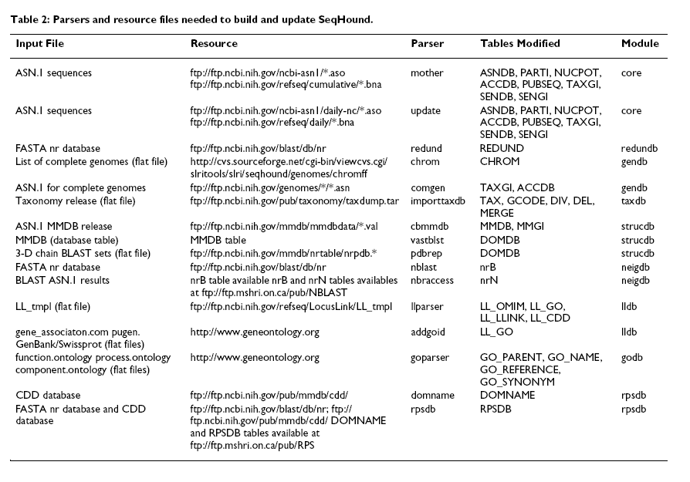

GUS 3.0 can handle a set of files types and input formats coming form wide set of resources, the following is a list of these resources:
- DNA Sequence DBs: GenBank (main, dbEST, NRDB), TIGR
- Protein Sequence DBs: Swiss-Prot, CDD, ProDom, InterPro
- Expression: MAGE
- Ontologies: GO, SO, PATO
- Mapping Data: RH maps
- Gene Predictors: GLIMMER, GENSCAN, Phat, GeneFinder
- Sequence Alignment: BLAST, BLAT, SIM4
- Sequence Assembly: CAP4
- Etc.
The following are the types of format that may be exported out of a GUS database:
- FASTA
- MAGE
- DB table dumps
- DoTS assemblies

Suggested Approach for prototype
There is two ways to go for handling this project and developing the Data Warehouse Schema:
- From Scratch (defining a set of simple tables and the relations that we need to implement between them )
- Using existing schema that represents the set of data which we need to store.

For both, we have also to add the ETL API to be used in order to populate the schema with data and record coming from available resources. Some of the existing schemas are also provided with loading APIs (i.e. ETL tools).

Staging DB (Hannes)
(see Schema on the wiki)

Preceding work in warehouse and their available API can be resumed by the following table

 | GUS | Atlas | Chado | BioSQL
API
DB Schema
…
…

Comparing Existing Warehousing approaches:
Description of Evaluation Criteria:

Technical Characteristics:
- Robustness: with heavy query (fails or not)
- Accepted Format: what are the format that they accept
- Speed with heavy query (time)
- Clarity of the API
- Conviviality of Administration
- Accessibility with many queries
- Concurrency Queries
- Existing API data sources
- Quality API from programming point of view
- Complexity of Queries : how difficult is to formulate a query, how many tables involved in a typical query
- DB schema : any extension is needed to answer requirements
- Storage Limits

Production and Maintenance Characteristics:
- Platform and production environment
- Liability Production
- Security
- Existing Administration Documentation, assistance and feedback
- Needed Maintenance
- Performance with multiple users in term of handling the same number of users existing as WB
- Loading/populating time
- Openness and Portability
- Volatility

Risks and Investments Characteristics:
- Platform Cost
- Complementary Development
- Time of Deployment
- Risk of dependency: case of no more supported

Evaluation Table
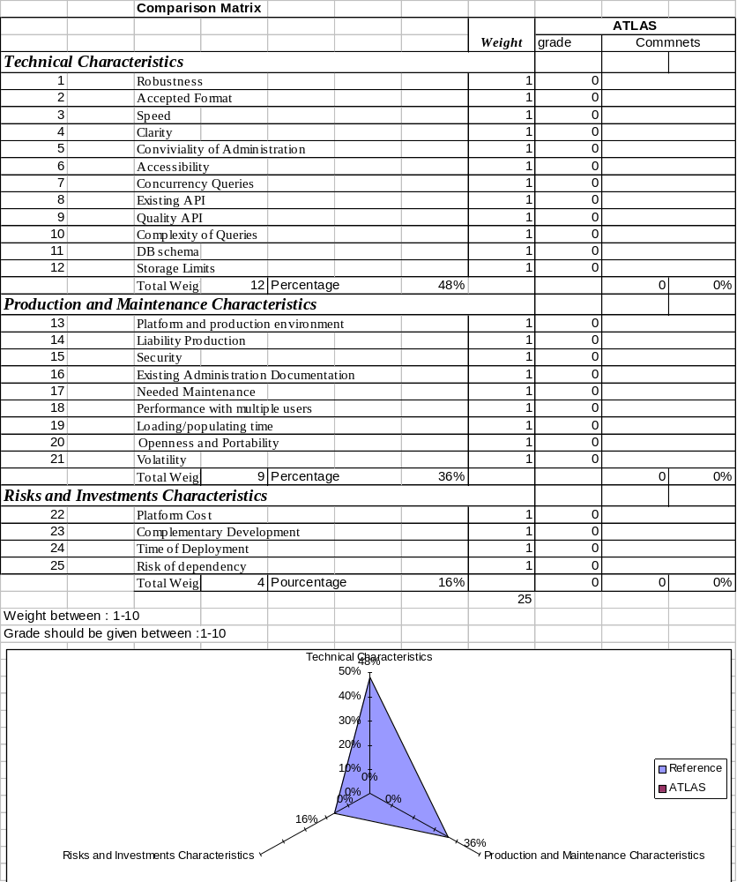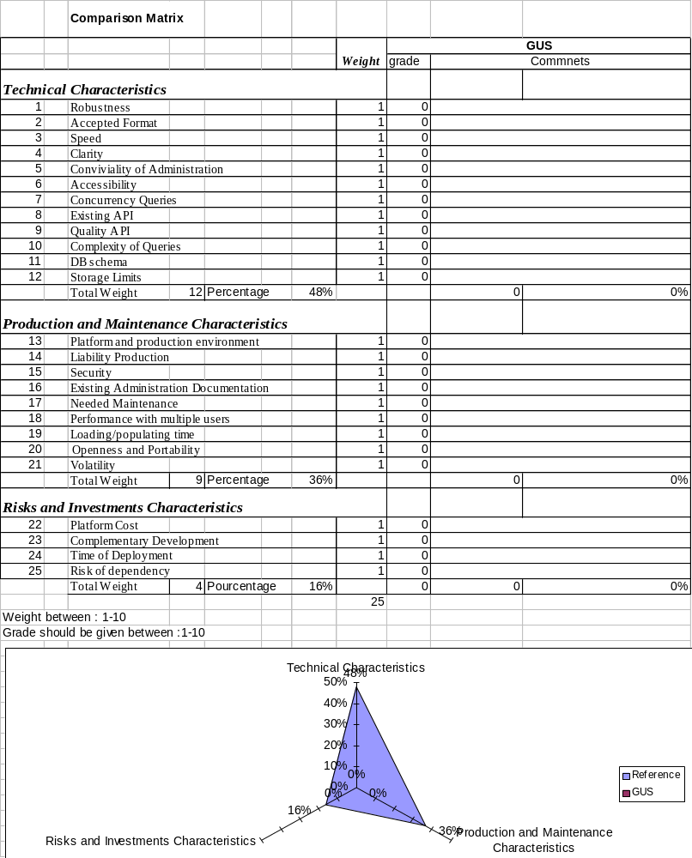

Which to use and Why

Implementation issues & APIs

What to install, where, how

Related Issues
Retrieval API:
Users, in general biologists and students want to interact with the system using the language taht they are used to understand. Biological terms and vocabulary should be used in order to simplify the querying system. In this respect, we should adopt biological data types in the accessibility API similar discussion about biological data types and Genomic Algebra is given in [5]. These API are highly related to the main architecture adopted for the Swami project. Therefore, architectural requirements, retrieval API, and implementation platform will be discussed in a separate document.

Queries optimization:
Dealing with integrated warehousing system provides the main advantage of implementing different optimization strategies that can help to speed the system query answering capabilities. In this respect, we should study these issues with the help of known techniques and tools. A deeper reflection should be done especially when new resources are being added to the warehouse system. The main priorities of the Swami is to have first the system up then finding the best practices that improve user experience and optimizing their time will be considered later on.

Use of ontologies (Query enhancement):
Many questions were raised concerning the usefulness of ontologies inside the Swami project. For instance, if the user queries a database with such an ambiguous term, he/She has full responsibility to verify the semantic congruence between what he/she asked for and what the database returned. An ontology helps here to establish a standardized, formally and coherently defined nomenclature in molecular biology. Each technical term has to be associated with a unique semantics that should be accepted by the biological community. These ideas will be discussed in a separated requirements document studying the use of ontologies.

Workflows:
One of the goals of Swami is to provide users with the possibility to compose a set of tools together in order to create a complete chain of processing for the data being treated. This type of process is known by workflows or pipelines. In this category, we can identify some projects such as: The Taverna project (aims to provide a language and software tools to facilitate easy use of workflow and distributed compute technology within the eScience community. As a component of the EPSRC funded ^{my}Grid project, Taverna is available freely under the terms of the GNU Lesser General Public License (LGPL). Biomoby: The MOBY system for interoperability between biological data hosts and analytical services. The MOBY-S system defines an ontology-based messaging standard through which a client will be able to automatically discover and interact with task-appropriate biological data and analytical service providers, without requiring manual manipulation of data formats as data flows from one provider to the next [7]. These ideas concerning the composition of the workflows and the use of semantics to simplify this task will be studied separately in other requirements document.

Managing Annotation: DAS: The Distributed Annotation System (DAS) allows merging of DNA sequence annotations from multiple sources and provides a single annotation view. A straightforward way to establish a DAS annotation server is to use the "Lightweight DAS" server (LDAS). Onto this type of server, annotations can be uploaded as flat text files in a defined format. The popular Ensembl ContigView uses the same format for the transient upload and display of user data.

Appendix (Similar projects)
Old Biology Workbench:
The database system for the old workbench can be broken into three layers. The presentation layer, the retrieval layer, and the indexer layer. The presentation layer was responsible for beautification of database records and was composed of a collections of perl scripts, and a library of common routines. The perl scripts would be passed the raw text of a record. They used regex to locate regular features of the record to identify the various attributes, which it would then markup for presentation. The markup would typically bold the attribute name, present the attribute data and name in table format, add the markup for any available hyperlinks to internal or external sources, and display a graphic if relevant and available.

The retrieval layer was composed of a unix "fgrep" command called from a custom C program. To achieve the ability to perform searches that utilized boolean logic, a perl wrapper was added that would perform the atomic searches, and then and/or/except the results together.

The indexer layer was a C program called ndjinn. It was controlled by a config file that specified the following information: record start pattern, record end pattern, record title pattern, record key pattern, word seperator characters, word skip list, location of data files to be indexed, and location data files would live when they went live. When the program was run, it would read the config file. Next it would read through the files that were to be indexed line-by-line, looking for all the patterns specified in the config file, maintaining a index of files as it progressed through them. Once a record end pattern matched, it would dump out the word lists, with occurance count to the index file, dump out the key to the key file, and the title to the title file. The format it stored the words was simple, beginning of line was the word, followed by a termination character, followed by structured binary data. This allowed for "fgrep" to be used to look for "^word:".

NC Bioportal Project: has been created to develop and deploy a shared, extensible bioinformatics portal that can be used to train North Carolina students and empower researchers. It also builds on experience operating a bioinformatics portal for statewide use as well as emerging toolkits and standards for portals, clusters and grids. The underlying architecture uses J2EE and JSP for web presentation.

MIGenAS: (Max Planck Integrated Gene Analysis System): MiGenAS provides an integrated environment for bioinformatics software tools and data for covering the processing chain from the sequences of DNA fragments (reads) on to the genome sequence (assembly), ORF prediction and function assignment (annotation), phylogenetic analysis, and models of the secondary and tertiary structures. MiGenAS is focused on research with microbial genomes, featuring convenient, "pipelined" and high-throughput applications.

References:
[1] NGWB NIH Proposal
[2] The Molecular Biology Database Collection: 2006 update, Galperin MY.
[3] Integration of biological sources: current systems and challenges ahead. Hernandez, T. and Kambhampati, S. 2004, SIGMOD Rec. 33, 3 (Sep. 2004),
[4] Swami Database Support
[5] J. Hammer and M. Schneider, "Genomics Algebra: A New, Integrating Data Model, Language, and Tool for Processing and Querying Genomic Information," CIDR'02, Asilomar, California, USA, 2002, pp. 176-187.
[6] Baker PG, Brass A, Bechhofer S, Goble C, Paton N, Stevens R. TAMBIS---transparent access to multiple bioinformatics information sources. Intelligent Systems for Molecular Biology 1998, 6:25--34. http://citeseer.ifi.unizh.ch/baker98tambis.html
[7] P. Lord, S. Bechhofer, M.D. Wilkinson, G. Schiltz, D. Gessler, D. Hull, C. Goble, and L. Stein. Applying Semantic Web Services to bioinformatics: Experiences gained, lessons learnt. ISWC, 2004. http://citeseer.ist.psu.edu/lord04applying.html
[8] Sohrab P Shah, Yong Huang, Tao Xu, Macaire MS Yuen, John Ling and BF Francis Ouellette. Atlas is a data warehouse for integrative bioinformatics. BMC Bioinformatics 2005, http://www.biomedcentral.com/content/pdf/1471-2105-6-34.pdf
[9] Query Answering in Inconsistent Databases. In Logics for Emerging Applications of Databases, J. Chomicki, R. van der Meyden, G. Saake, editors, Springer-Verlag, 2003 (with Leopoldo Bertossi).
[10] Davidson, S. B., Crabtree, J., Brunk, B. P., Schug, J., Tannen, V., Overton, G. C., and Stoeckert, C. J. 2001. K2/Kleisli and GUS: experiments in integrated access to genomic data sources. IBM Syst. J. 40, 2 (Feb. 2001), 512-531.

